10/100Mbps Fiber Media Converter
10/100Base-TX to 100Base-FX ( HS130 Series)

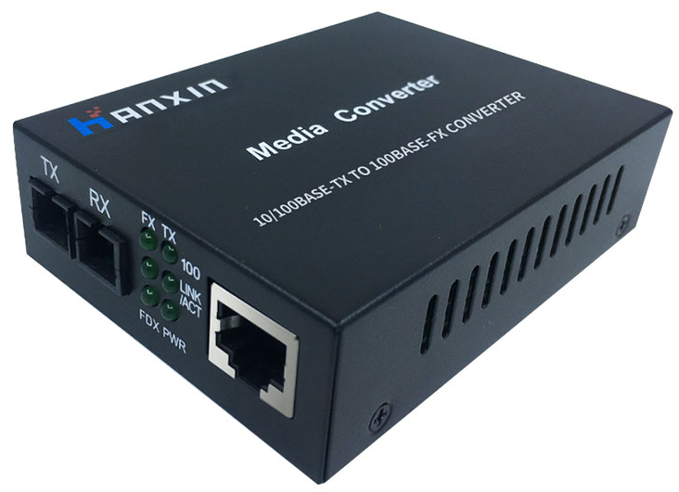
Dual Fiber Single/ Multi Mode (Model:HS130-MSC-2/HS130-SSC-20/40/60/80/120)
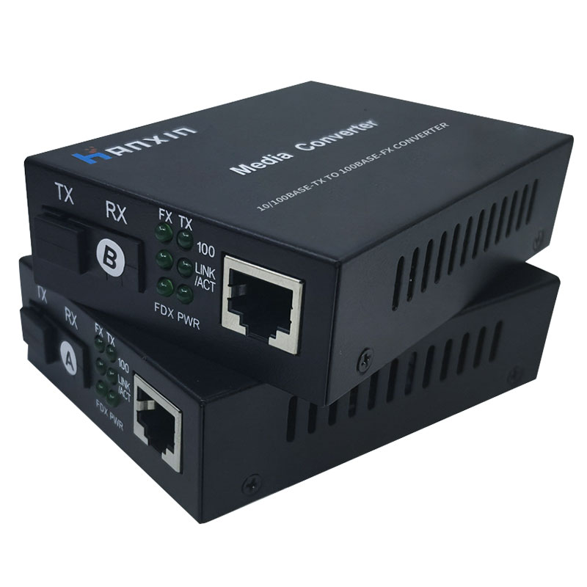
Single Fiber Single/Multi Mode (Model:HS140-SSC-20/40/60/80/120)
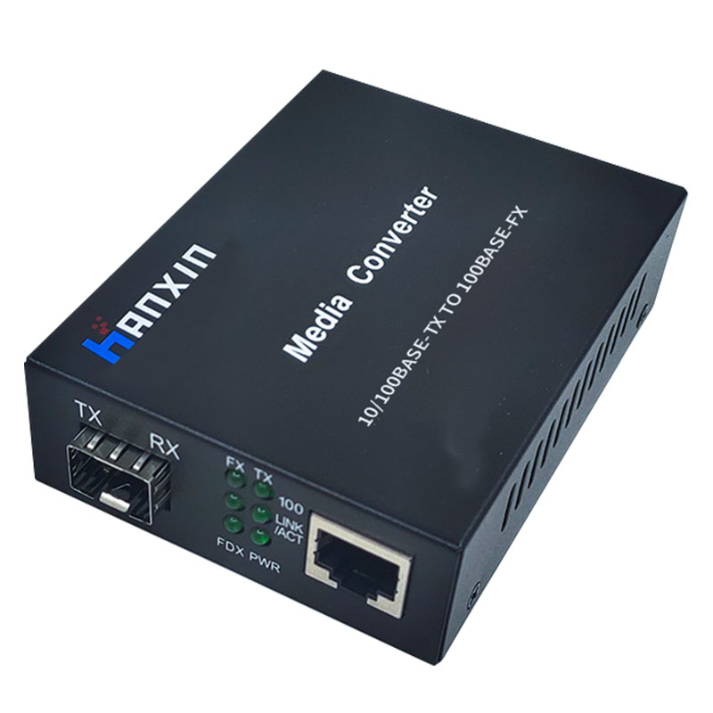
Model:HS130-SFP
Overview
The HanXin 10/100Mbps Fiber media converters are designed to transmit and receive 10/100Mbps data over one optical fiber. The electrical interface will Auto-Negotiate to a 10Mbps, or 100Mbps Ethernet rate without any adjustments. The optical interface operates at a 100Mbps Ethernet rate. LED indicators are provided for rapidly ascertaining equipment operating status.

Key Features
1. Plug and play, high performance, Low power consumption
2. Complies with IEEE802.3 (10BASE-T) and IEEE802.3u (100BASE-TX/FX) standards
3. Auto-negotiation support on RJ45 port
4. Auto-Negotiation of duplex(HDX/FDX) on RJ45 port
5.Electrical port supports Auto-Negotiation for 10Mbps or 100Mbps, full duplex or half duplex data.
6. Auto MDI/MDI-X support on RJ45 port
7. Distances up to: 2 km Multimode, 120 km Single Mode
8. ST, SC, FC optical connectors
9. Status LED's for TX,FX LINK/ACT, POWER,100M to easily monitor network status
10.External power adapter

Applications
►Access Control Systems
►Building and Environmental Control Systems
►Tamper Switch
►High Speed Computer Links

Technical Specifications
Parameters | Specifications
Standards | IEEE802.3u (100Base-TX/FX), IEEE 802.3 (10Base-T)
Wavelength | Multi-mode: 850 nm or 1310nm  Single-mode: 1310 nm , 1550 nm
Transmission Distance | Fiber:  Multi-mode: 2 km (fiber size: 62.5/125 or 50/125 μm)  Single-mode: 20/40/60/100/120 km  UTP:  Cat. 3/4/5/6: 100 m
Port | One RJ45 port  One Fiber port (ST/SC/FC Optional, LC:SFP Module)
MDI/MDI-X | Auto selection
MAC Address Table | I K
Buffer Size | 1Mbit
Flow Control | Duplex:flow control ; Half duplex:back pressure
Time Delay | Store-and-forward:9.6us,Straight-through:0.9us
BER | <1/1000000000
Power Supply | Outside: 5 V DC 1 A  Built-in: 100 V to 265V AC 50 Hz to 60 Hz
Operating Temp. | 0 °C to +70 °C
Storage Temp. | -20 °C to +80 °C
Relative Humidity | 5% to 90% (non-condensing)
Dimensions | 95 mm × 70 mm × 25 mm
Net Weight | 0.165 kg

Connection Diagram
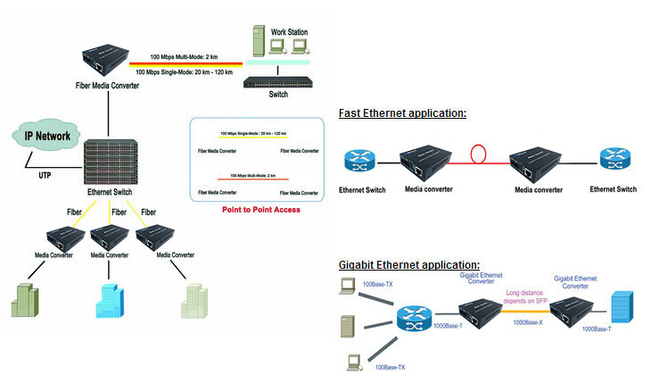

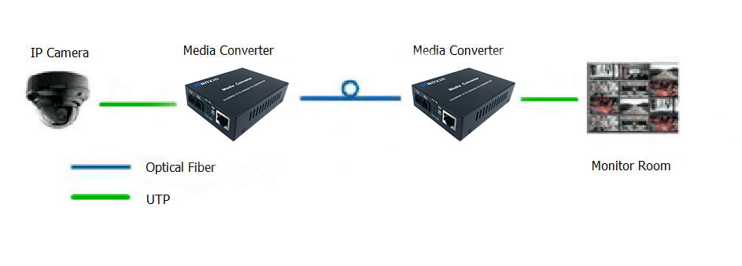
Ordering Information
Model | Description | Fiber Mode | Wavelength | Distance | Connector
HS130-MSC-2 | 10/100Base-Tx to 100Base-FX | MMF | TRx:850nm  or TRx:1310nm | 2km | SC
HS130-SSC-20 | 10/100Base-Tx to 100Base-FX | SMF | TRx:1310nm | 25 km | SC
HS130-SSC-40 | 10/100Base-Tx to 100Base-FX | SMF | TRx:1310nm | 40 km | SC
HS130-SSC-60 | 10/100Base-Tx to 100Base-FX | SMF | TRx:1550nm | 60 km | SC
HS130-SSC-80 | 10/100Base-Tx to 100Base-FX | SMF | TRx:1550nm | 80 km | SC
HS130-SSC-120 | 10/100Base-Tx to 100Base-FX | SMF | TRx:1550nm | 120 km | SC
HS130-SFP | 10/100Base-Tx to 100Base-FX |  |  |  | SFP
HS140-SSC-25 | 10/100Base-Tx to 100Base-FX | SMF | A side: Tx1310 nm/ Rx1550 nm  B side: Tx1550 nm/ Rx1310 nm | 25 km | SC
HS140-SSC-40 | 10/100Base-Tx to 100Base-FX | SMF | A side: Tx1310 nm/ Rx1550 nm  B side: Tx1550 nm/ Rx1310 nm | 40 km | SC
HS140-SSC-60 | 10/100Base-Tx to 100Base-FX | SMF | A side: Tx1310 nm/ Rx1550 nm  B side: Tx1550 nm/ Rx1310 nm | 60 km | SC
HS140-SSC-80 | 10/100Base-Tx to 100Base-FX | SMF | A side: Tx1310 nm/ Rx1550 nm  B side: Tx1550 nm/ Rx1310 nm | 80 km | SC
HS140-SSC-120 | 10/100Base-Tx to 100Base-FX | SMF | A side: Tx1310 nm/ Rx1550 nm  B side: Tx1550 nm/ Rx1310 nm | 120 km | SC

