10/100/1000Mbps Fiber Media Converter
10/100/1000Base-TX to 1000Base-FX HS1200-SSC Series
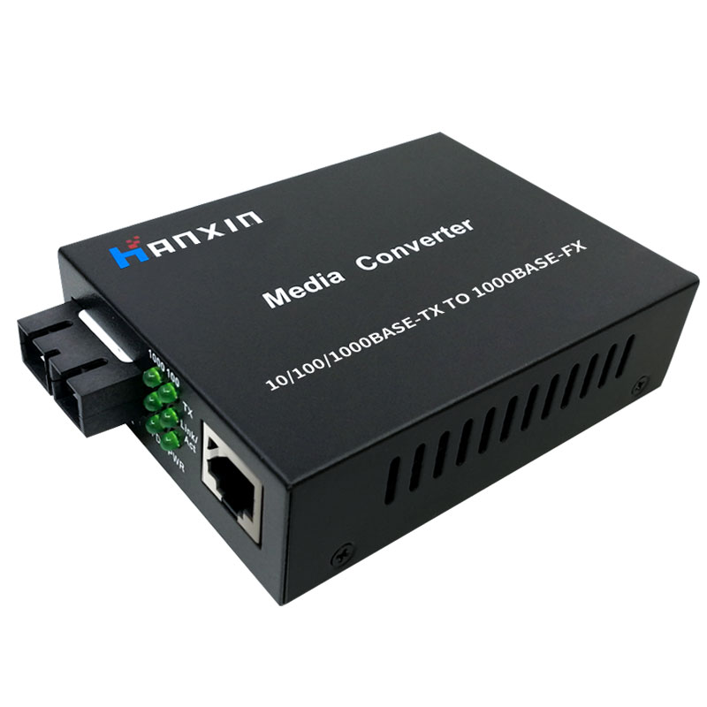HS1200-SSC Series
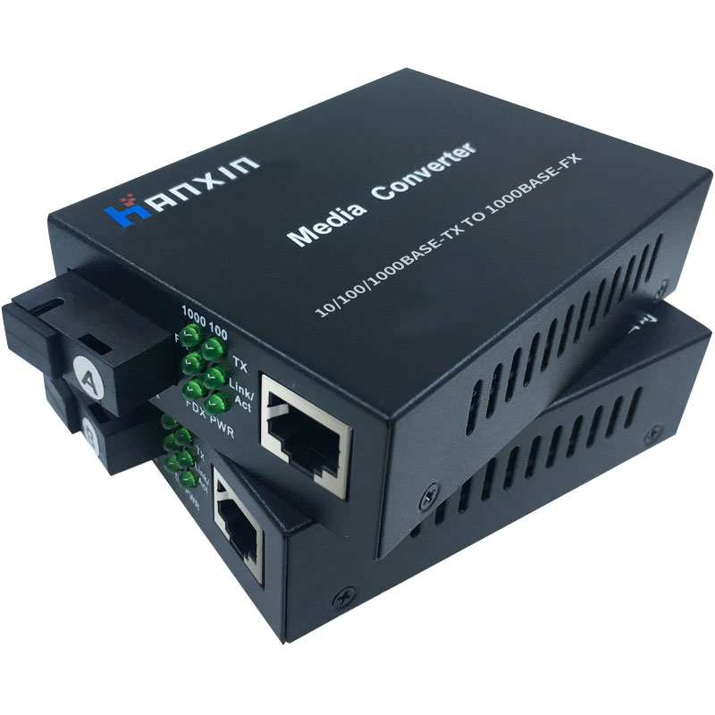 HS1200D-SSC Series
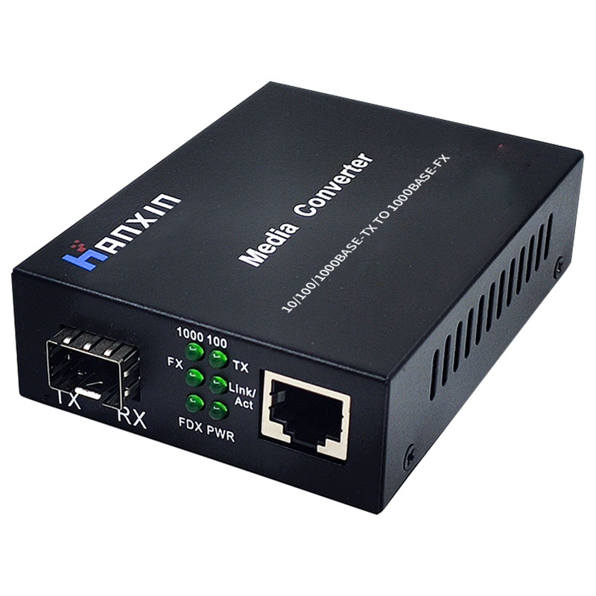HS1200-SFP
General Description
The HS1200 Series Gigabit Ethernet Media Converters with external power supply are designed to transmit and receive 10/100/1000Mbps data over optical fiber. The electrical interface will Auto-Negotiate to a 100 Mbps or 1000Mbps Ethernet rate without any adjustments. The optical interface operates at a 1000 Mbps Ethernet rate. Both are environmentally hardened to operate in extreme temperatures. LED indicators are provided for confirming equipment operating status.
Features:
-10/100/1000Mbps Ethernet
-10/100/1000 BASE-T/TX electrical port
-1000 BASE-SX/LX optical port
-Electrical port supports Auto-Negotiation for 100Mbps or 1000Mbps, full duplex or half duplex data.
-Optical port supports 1000Mbps full duplex data
-Automatic MDI/MDI-X crossover
-Distances up to 2km for Multi mode;Up to 120km for Single mode
-Voltage transient protection on all power and signal input.output lines provides unconditional protection from power surges and other voltage transient events
-No in-field optical adjustments required
-LED Indicators

Applications:
--Access Control Systems
--Building and Environmental Control Systems
--Tamper Switch
--High Speed Computer Links

Parameter
Parameters | Specifications
Standards | IEEE 802.3 10Base-T  IEEE 802.3u 100Base-TX  IEEE 802.3ab 1000Base-TX/FX
Optic Wavelength | HS1200-MSC: 850nm  HS1200-SSC: 1310nm  HS1200-SFP: N/A  HS1200D-SSC-20A:TX:1310nm/RX:1550nm  HS1200D-SSC-20B:TX:1550nm/RX:1310nm
Transmission Distance | Multimode: 2km  Single mode:10km~120km
Port | Optical: 2 Fibers (SC/ST/FC Optional)  Power: Terminal Block  Electrical: RJ45
Led Indicators | Optical Link/Data Activity  Electrical Link/Data Activity
MDI/MDI-X | Auto selection
Mac address table | 4K
Memory buffer | 256K
Jumbo Frame | 9216 bytes
Data | Data Interface: Ethernet  Data Rate:10/100/1000 Mbps
Power Supply | External : 5V DC 1A  Built-in: 100 V to 240 V AC 50Hz to 60 Hz  Power Consumption : ≤5W
Operating Temperature | 0 °C to +70 °C
Storage Temperature | -20 °C to +80 °C
Relative Humidity | 5% to 90% (non-condensing)  MTBF: >100,000 hours
Dimensions | 95mm * 70 mm * 26mm
Net Weight | 0.165 kg
Emissions | FCC , RoHS, CE Mark

Ordering Information
Part Number | Description
HS1200-MSC-550 | Multi-mode Dual Fiber 10/100/1000M 850nm 550M SC to RJ45 External Power Supply
HS1200-SSC-20 | Single-mode Dual Fiber 10/100/1000M 1310nm 20KM SC to RJ45 External Power Supply
HS1200-SSC-40 | Single-mode Dual Fiber 10/100/1000M 1310nm 40KM SC to RJ45 External Power Supply
HS1200-SSC-60 | Single-mode Dual Fiber 10/100/1000M 1550nm 60KM SC to RJ45 External Power Supply
HS1200-SSC-80 | Single-mode Dual Fiber 10/100/1000M 1550nm 80KM SC to RJ45 External Power Supply
HS1200-SSC-120 | Single-mode Dual Fiber 10/100/1000M 1550nm 120KM SC to RJ45 External Power Supply
HS1200D-SSC-20 | Single-mode Bidirection 10/100/1000M 20KM SC to RJ45 External Power Supply  HS1200D-SSC-20A TX:1310nm/RX1550nm  HS1200D-SSC-20B TX:1550nm/RX1310nm
HS1200D-SSC-40 | Single-mode Bidirection 10/100/1000M 40KM SC to RJ45 External Power Supply  HS1200D-SSC-40A TX:1310nm/RX1550nm  HS1200D-SSC-40B TX:1550nm/RX1310nm
HS1200D-SSC-60 | Single-mode Bidirection 10/100/1000M 60KM SC to RJ45 External Power Supply  HS1200D-SSC-60A TX:1310nm/RX1550nm  HS1200D-SSC-60B TX:1550nm/RX1310nm
HS1200D-SSC-80 | Single-mode Bidirection 10/100/1000M 80KM SC to RJ45 External Power Supply  HS1200D-SSC-80A TX:1310nm/RX1550nm  HS1200D-SSC-80B TX:1550nm/RX1310nm
HS1200D-SSC-120 | Single-mode Bidirection 10/100/1000M 120KM SC to RJ45 External Power Supply  HS1200D-SSC-120A TX:1310nm/RX1550nm  HS1200D-SSC-120B TX:1550nm/RX1310nm
HS1200-SFP | 1 SFP Port 1000M RJ45Port External Power Supply

Application Diagram
