 SFP-FE-S13-10
155Mb/s 1310nm Single-mode SFP Transceiver

PRODUCT FEATURES
- Up to 155Mb/s data links
- FP laser transmitter and PIN photo-detector
- Up to 10km on 9/125µm SMF
- Hot-pluggable SFP footprint
- Duplex LC/UPC type pluggable optical interface
- Low power dissipation
- Metal enclosure, for lower EMI
- RoHS compliant and lead-free
- Single +3.3V power supply
- Compliant with SFF-8472
- Case operating temperature
Commercial: 0°C to +70°C
Extended: -10°C to +80°C
Industrial: -40°C to +85°C

APPLICATIONS
- Switch to Switch Interface
- Fast Ethernet
- Switched Backplane Applications
- Router/Server Interface
- Other Optical Links

PRODUCT DESCRIPTION
SFP-FE-S13-10 Small Form Factor Pluggable (SFP) transceivers are compatible with the Small Form Factor Pluggable Multi-Sourcing Agreement (MSA). The transceiver consists of four sections: the LD driver, the limiting amplifier, the 1310nm FP laser and the PIN photo-detector .The module data links up to 10KM in 9/125um single mode fiber.

The optical output can be disabled by a TTL logic high-level input of Tx Disable. Tx Fault is provided to indicate that degradation of the laser. Loss of signal (LOS) output is provided to indicate the loss of an input optical signal of receiver or the link status with partner.

Ordering information
Product part Number | Data Rate  (Mbps) | Media | Wavelength  (nm) | Transmission  Distance(km) | Temperature Range(Tcase)  （℃）
SFP-FE-S13-10 | 155 | single mode fiber | 1310 | 10 | 0~70 | commercial

- Pin Descriptions
Pin | Symbol | Name/Description | NOTE
1 | VEET | Transmitter Ground (Common with Receiver Ground) | 1
2 | TFAULT | Transmitter Fault.
3 | TDIS | Transmitter Disable. Laser output disabled on high or open. | 2
4 | MOD_DEF(2) | Module Definition 2. Data line for Serial ID. | 3
5 | MOD_DEF(1) | Module Definition 1. Clock line for Serial ID. | 3
6 | MOD_DEF(0) | Module Definition 0. Grounded within the module. | 3
7 | Rate Select | No connection required | 4
8 | LOS | Loss of Signal indication. Logic 0 indicates normal operation. | 5
9 | VEER | Receiver Ground (Common with Transmitter Ground) | 1
10 | VEER | Receiver Ground (Common with Transmitter Ground) | 1
11 | VEER | Receiver Ground (Common with Transmitter Ground) | 1
12 | RD- | Receiver Inverted DATA out. AC Coupled
13 | RD+ | Receiver Non-inverted DATA out. AC Coupled
14 | VEER | Receiver Ground (Common with Transmitter Ground) | 1
15 | VCCR | Receiver Power Supply
16 | VCCT | Transmitter Power Supply
17 | VEET | Transmitter Ground (Common with Receiver Ground) | 1
18 | TD+ | Transmitter Non-Inverted DATA in. AC Coupled.
19 | TD- | Transmitter Inverted DATA in. AC Coupled.
20 | VEET | Transmitter Ground (Common with Receiver Ground) | 1

Notes:
- Circuit ground is internally isolated from chassis ground.
- Laser output disabled on TDIS >2.0V or open, enabled on TDIS <0.8V.
- Should be pulled up with 4.7k - 10kohms on host board to a voltage between 2.0V and 3.6V.MOD_DEF (0) pulls line low to indicate module is plugged in.
- This is an optional input used to control the receiver bandwidth for compatibility with multiple data rates (most likely Fiber Channel 1x and 2x Rates).If implemented, the input will be internally pulled down with > 30kΩ resistor. The input states are:
  - Low (0 – 0.8V): Reduced Bandwidth
  - (>0.8, < 2.0V): Undefined
  - High (2.0 – 3.465V): Full Bandwidth
  - Open: Reduced Bandwidth
- LOS is open collector output should be pulled up with 4.7k - 10k ohms on host board to a voltage between 2.0V and 3.6V. Logic 0 indicates normal operation; logic 1 indicates loss of signal.
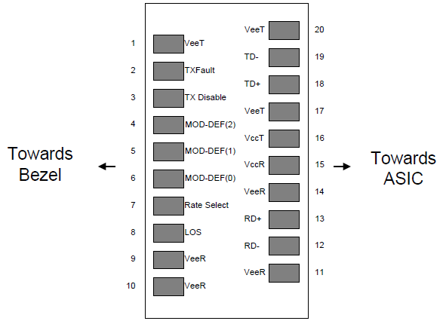
Figure2. Pin out of Connector Block on Host Board
II. Absolute Maximum Ratings
Parameter | Symbol | Min. | Typ. | Max. | Unit | Note
Storage Temperature | Ts | -40 |  | 85 | ºC
Relative Humidity | RH | 5 |  | 95 | %
Power Supply Voltage | VCC | -0.5 |  | 4 | V
Signal Input Voltage |  | -0.3 |  | Vcc+0.3 | V
Receiver Damage Threshold |  | 5 |  |  | dBm

III. Recommended Operating Conditions
Parameter | Symbol | Min. | Typ. | Max. | Unit | Note
Case Operating Temperature | Tcase | 0 |  | 70 | ºC | SFP-1303-10BD
Case Operating Temperature | Tcase | -10 |  | 80 | ºC | SFP-1303-10BDE
Case Operating Temperature | Tcase | -40 |  | 85 | ºC | SFP-1303-10BDA
Power Supply Voltage | VCC | 3.13 | 3.3 | 3.47 | V
Power Supply Current | ICC |  |  | 280 | mA
Power Supply Noise Rejection |  |  |  | 100 | mVp-p | 100Hz to 1MHz
Data Rate |  |  | 155/155 |  | Mbps | TX Rate/RX Rate
Transmission Distance |  |  |  | 10 | KM
Coupled Fiber | Single mode fiber |  |  |  |  | 9/125um SMF

- Specification of Transmitter
Parameter | Symbol | Min. | Typ. | Max. | Unit | Note
Average Output Power | POUT | -15 |  | -7 | dBm | Note (1)
Extinction Ratio | ER | 8.2 |  |  | dB
Center Wavelength | λC | 1270 | 1310 | 1360 | nm | FP Laser
Spectrum Width (RMS) | σ |  |  | 3.5 | nm
Transmitter OFF Output Power | POff |  |  | -45 | dBm
Differential Line Input Impedance | RIN | 90 | 100 | 110 | Ohm
Output Eye Mask | Compliant with G.957(class 1 laser safety) |  |  |  |  | Note (2)

Note (1): Measured at 2^23-1 NRZ PRBS pattern.
Note (2): Transmitter eye mask definition.

V. Specification of Receiver
Parameter | Symbol | Min. | Typ. | Max. | Unit | Note
Input Optical Wavelength | λIN | 1270 |  | 1610 | nm
Receiver Sensitivity | PIN |  |  | -29 | dBm | Note (1)
Input Saturation Power (Overload) | PSAT | -8 |  |  | dBm
Los Of Signal Assert | PA |  |  | -30 | dBm
Los Of Signal De-assert | PD | -45 |  |  | dBm | Note (2)
LOS Hysteresis | PA-PD | 0.5 | 2 | 6 | dB

Note (1): Measured with Light source 1310nm, ER=8.2dB; BER =<10^-12 @PRBS=2^23-1 NRZ.
Note (2): When LOS de-asserted, the RX data+/- output is High-level (fixed)

VI. Electrical Interface Characteristics
Parameter | Symbol | Min. | Typ. | Max. | Unit | Note
Transmitter
Total Supply Current | ICC |  |  | A | mA | Note (1)
Transmitter Disable Input-High | VDISH | 2 |  | Vcc+0.3 | V
Transmitter Disable Input-Low | VDISL | 0 |  | 0.8 | V
Transmitter Fault Input-High | VTxFH | 2 |  | Vcc+0.3 | V
Transmitter Fault Input-Low | VTxFL | 0 |  | 0.8 | V
Receiver
Total Supply Current | ICC |  |  | B | mA | Note (1)
LOSS Output Voltage-High | VLOSH | 2 |  | Vcc+0.3 | V | LVTTL
LOSS Output Voltage-Low | VLOSL | 0 |  | 0.8 | V | LVTTL

Note (1): A (TX) + B (RX) = 280mA (Not include termination circuit)
VII. Recommend Circuit Schematic
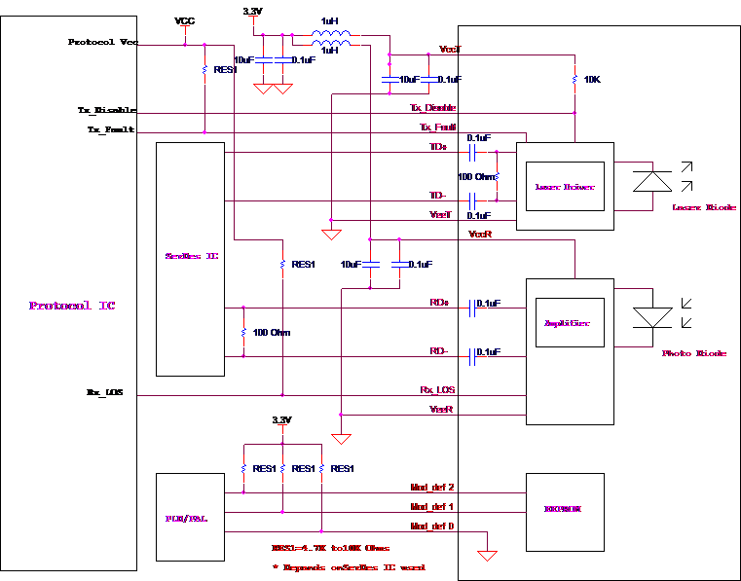

VIII. Mechanical Specifications (Unit: mm)
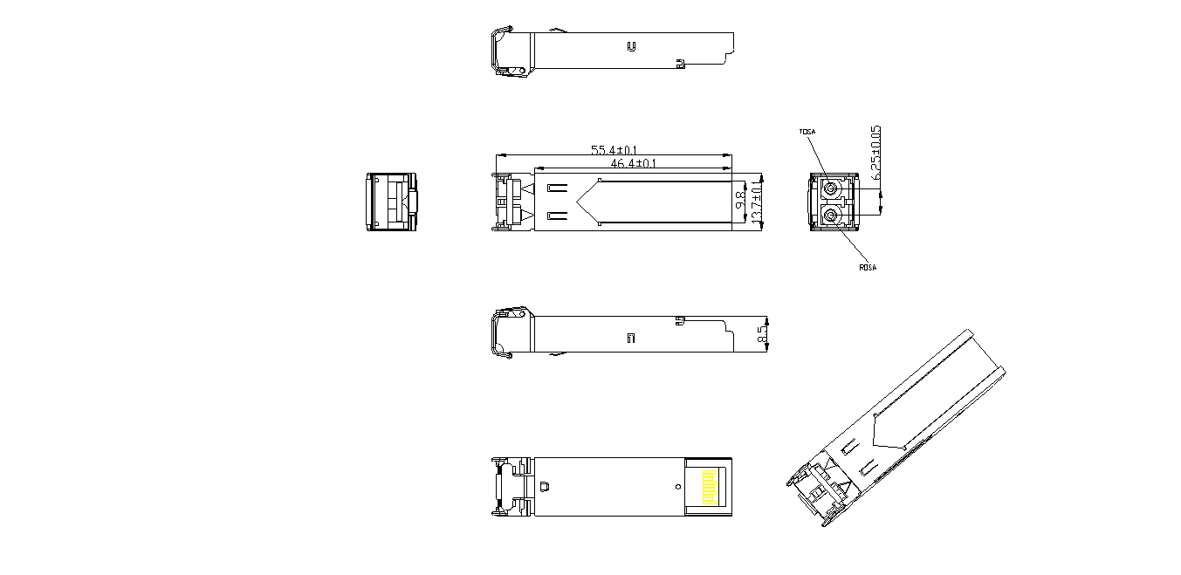
SFP-FE-S13-10
- Regulatory Compliance
Feature | Reference | Performance
Electrostatic discharge（ESD） | IEC/EN 61000-4-2 | Compatible with standards
Electromagnetic Interference (EMI) | FCC Part 15 Class B EN 55022 Class B (CISPR 22A) | Compatible with standards
Laser Eye Safety | FDA 21CFR 1040.10, 1040.11 IEC/EN 60825-1，2 | Class 1 laser product
ROHS | 2002/95/EC | Compatible with standards
EMC | EN61000-3 | Compatible with standards

